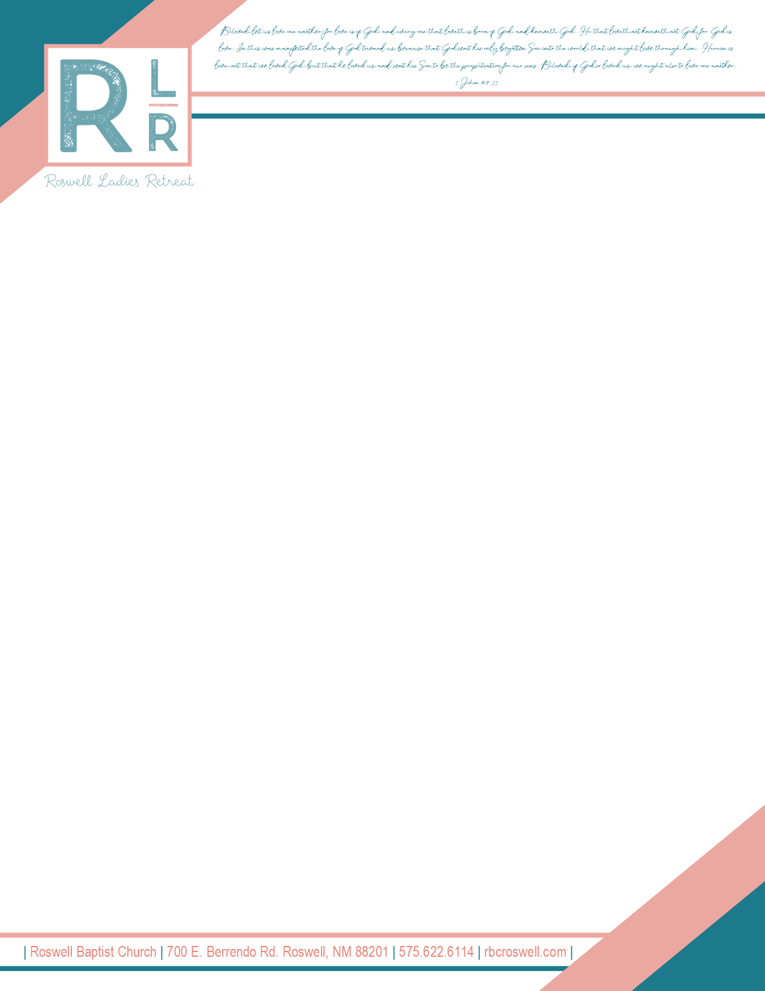

Dear Pastor’s Wife,

Hello! The ladies of Roswell Baptist Church would like to extend an invitation to our ladies retreat here in Roswell, NM on **October 4-5, 2024!** The Lord blessed us in more ways than we could ever imagine last year! We are still rejoicing!

This year’s theme, “Herein is Love…”, comes from the scripture *1 John 4: 9-10*. We pray, by God’s grace, to present a refreshing truth, that God is love. We are blessed to have Mrs. Angie Gaddis speaking for us, and Kellie Hamilton along with other ladies in the region, providing special music. I am confident their skilled gifts will be a refreshment to you and the content will communicate our themed Biblical principles well.

The cost is **$60 per person** for any lady 15 years of age and up (*Please, no children under 15).* This includes a comfortable facility, sessions with skilled teaching/music, craft materials, a “midnight snack” on Friday evening, and lunch on Saturday. We will be hosting the retreat at the **Roswell Civic Center** on **912 N. Main St.**

Please register online at *www.rbcroswell.com/ladies-retreat*. Registration will open **August 5th** and close **September 2nd.** We are capping off attendance this year to 312 people and hope to grow in the future! The response from last year and the anticipation for this year has been incredible, so I urge you to register quickly if you and your ladies desire to attend!

Love and Prayers,

Joellen Walden

joellen.walden@rbcroswell.com

405-820-7592

**Accommodations**

The hotels below have made special pricing arrangements for our retreat. Please mention “Roswell Baptist Church Ladies Retreat” when reserving your rooms.

We urge you to reserve your rooms as soon as possible, as they will release unclaimed rooms by September 29th.

**FAIRFIELD INN & SUITES**  **TOWNEPLACE SUITES**

$139 + TAX $129 + TAX

1201 N. MAIN ST. 180 E. 19th ST.

575-623-4021 575-622-5460

**HOLIDAY INN EXPRESS** **HOLIDAY INN**

$129 + TAX $98 + TAX

3 MILITARY HEIGHTS DR. 3620 N. MAIN ST.

575-208-0736 575-623-3216

**LA QUINTA INN & SUITES**  **CANDLEWOOD SUITES**

$99 + TAX $84 + TAX

200 E. 19th ST. 4 MILITARY HEIGHTS DR.

575-622-8000 575-623-4300

**HAMPTON INN & SUITES**

$99 + TAX

3607 N. MAIN ST.

575-623-5151

**General Schedule**

**Friday, October 4th**

3:00 PM Check-In

Turn In Gift Baskets

Turn In Blessings Boutique Items

Set up Craft Sale Booth

5:30 PM Check-In Closed

6:00 PM Session #1 Begins

**Saturday, October 5th**

8:00 AM Blessings Boutique/Craft Sale Open

9:00 AM Session #2 Begins

10:00 AM Blessings Boutique/Craft Sale Open

10:45 AM Session #3 Begins

12:00 PM Lunch

**Check In**

Please feel welcome to come early and enjoy shopping/dining out before the retreat starts! We ask that the Pastor’s wife or a representative of the church check in between the hours of 3:00 pm and 5:30 pm. At check in you will be able to drop off “Blessings Boutique” items, set up a booth at the Craft Sale, update contact information, acquire seating for your ladies, and receive your mandatory wristbands.

**Blessings Boutique**

We are excited for the second Blessings Boutique dress and purse sale! This is a boutique where you can buy and sell used or new women’s and girl’s dresses, skirts, and gently used purses. We will have designated times during our retreat that the Blessings Boutique will be open for shopping. The goal is to offer a fun shopping experience where you can purchase items to add to your wardrobe at an affordable price. It can also be a way to help motivate you to clean out your closet and make extra cash! Please bring cash for shopping (small bills are best). All items will be priced at $5.00 and under. If you wish to sell items at the Blessings Boutique, please see the attached detailed instruction page. Thank you in advance for following the detailed instructions. If you are selling items, please turn them in between 3:00-5:00pm on Friday, October 4th. All items must be tagged with a price, your assigned number, and size. You will need to text Autumn Fuentes at 575-973-3742 in advance to get an assigned number. Please call Autumn if you have any other questions!

**Craft Sale**

We are excited to offer a Craft Sale this year! If you are interested in just shopping, please bring some extra cash-many vendors may only be able to receive cash, not cards. If you are interested in running a booth to sell your creations, please text Mrs. Walden at 405-820-7592 with your name, email address, and products you plan on selling. In return, you will receive a confirmation email with further instructions ASAP. If you do not receive an email back in a timely manner, please feel free to reach out to the prior phone number. The price to run a booth at the Craft Sale will be 25$.

**Gift Baskets Give Aways**

Each lady in attendance at Ladies Retreat will be given a wristband with an assigned number. During the sessions we will have periodic drawings to give away gift baskets that our visiting churches have brought. Let me tell you… the ladies in this region know how to make the most elaborate, thoughtful, and impressive gift baskets I have ever seen! *Please do not feel any pressure to bring a gift basket,* you are still eligible for the drawings even if you do not bring a gift basket. Whether your church brings fifteen baskets or one, we are *very* appreciative of your contribution. If you have any more questions about the gift basket give aways, please email Mrs. Walden at [joellen.walden@rbcroswell.com](mailto:joellen.walden@rbcroswell.com).



Roswell Ladies Retreat 2024

Signup

Sign-Up sheet is for your convenience only. Registration is online.

